

Chicken Marinade Recipe

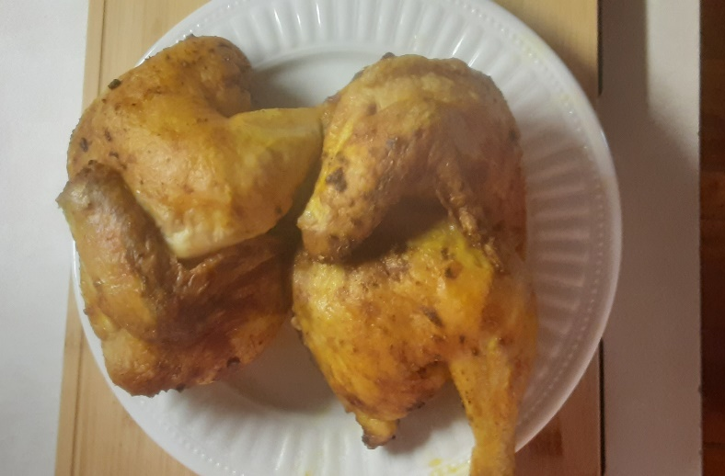
Here’s what you need:
- 2 cloves Garlic
- 1 tbsp. lime juice
- 1 tbsp. olive oil
- 1 tsp. chili powder
- 1 tsp. cumin
- 2 tsp. paprika
- 2 tsp. curry powder
- 1 tsp. salt
- ½ tsp. oregano
- ½ tsp. black pepper
- ¼ cup brown sugar

PREPARE
Combine all ingredients. Rub onto chicken. Put into zip lock back or covered bowl, pouring any excess marinade over top. Put in refrigerator for 1-2 hours or overnight.

